**DEPARTMENT B FOODS**

PREMIUMS: FIRST - $5.00; SECOND - $3.00; THIRD - $2.00

**RULES**

1. Baked goods must be displayed on rigid disposable plates and covered with clear re-sealable plastic bag.
2. All canned products and pickles must be in clear glass **regulation canning jars and properly sealed.** Canned products not in regulation jars (i.e. mayonnaise, peanut butter, pickle, etc.) will not be accepted. No paraffin on jelly.
3. Jellies, jams, preserves and pickles may be opened for judging.
4. Rings must be on jars.
5. General Rules and Regulations apply.
6. The Ball Blue Book recommendations will be used as the criteria when determining if a product is accepted for judging.
7. Baked goods that become visually unattractive will be discarded.
8. No canned foods will be accepted with rust on lids or rings.
9. Canned products not sealed will not be accepted for entry.
10. Canned foods judged on appearance only. Judges will not taste canned

foods.

**SECTION I – BREADS**

PREMIUMS: FIRST - $5.00; SECOND - $3.00; THIRD - $2.00

Standards

LOOKS: tender and good, even, golden brown color, good shape

TEXTURE: fine, even grain, small thin cell walls, light for size, crisp crust

CRUMB: creamy white, slightly moist, light and elastic, tender

FLAVOR: good, well-blended flavor, pleasing

CLASS

1. Three rolls
2. Light loaf bread (½ loaf)
3. Quick sweet bread (½ loaf or whole small loaf)
4. Yeast sweet bread (½ loaf or 3 rolls)
5. Three biscuits
6. Cornbread – two pieces
7. Cornbread – muffins or sticks (2)
8. Muffins (2)
9. Sourdough (½ loaf)
10. Scones
11. Anything made from canned biscuits

**SECTION II – SPECIAL BREAD CATEGORY (½ LOAF)**

FIRST - $15.00; SECOND - $10.00; THIRD - $7.00

All entries in this category must be made from the following recipe contributed by Mrs. Kenton Chittum.

2 tablespoons shortening 1 cup scalded milk

1 cup boiling water 1 yeast cake softened in

2 tablespoons sugar ¼ cup lukewarm water

2 teaspoons salt 6 to 6½ cups all-purpose bread flour

Put shortening, sugar and salt in a large bowl without a lid, or in top of large double broiler. Add liquids. Cool to lukewarm. Add yeast. Stir in 3 cups of flour. Mix thoroughly. Add 2 cups of flour, mix and add remaining flour gradually, using just enough to prevent sticking to the bowl.

Put the last ½ cup of flour on the mixing board or cloth and use some of it to dust the board very lightly, pushing the rest aside to work into the dough, if you need it. Turn the ball of dough out onto the board, leaving a clean bowl. Cover and let “rest” 10 minutes, which makes the dough easier to work with.

Knead, let rise, punch down and shape. Let rise until double in bulk (about one hour) and bake. Bake at 375° for 15 minutes and lower oven temperature to 350° and continue baking for 25 to 30 minutes. Your loaf should have a hollow sound when “plunked” on the top.

**CAG00007**

**SECTION III – SPECIAL CAKES (½ Cake)**

PREMIUM: FIRST - $15.00; SECOND - $10.00; THIRD - $7.00

1. All entries in this category must be made from a Dolly Parton Banana cake mix.
2. It may be changed any way desired by cook other than the quantity.
3. Cake will be judged on originality, taste, and appearance. Any frosting or filling may be included.
4. Recipe must be submitted with entry.

**SECTION IV – THEME CAKE – “COUNTRY ROOTS & COWBOY BOOTS”**

PREMIUM: FIRST - $20.00; SECOND - $15.00; THIRD - $7.00

1. Entries may be from scratch or boxed mix.

2. Entries may exhibit theme both inside and outside of cake

3. Entries will be cut

4. Cake will be judged on originality, taste, and appearance. Any frosting or filling may

be included.

**SECTION V – SPECIAL ROLLS (Refrigerator Rolls)**

PREMIUM: FIRST - $15.00; SECOND - $10.00; THIRD - $7.00

3 Rolls on Paper Plate in Plastic Bag

INGREDIENTS

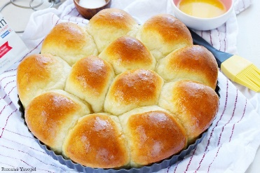¾ C Hot Water

½ C Sugar

1 Tablespoon Salt

3 Tablespoons Margarine

1 C Warm Water

2 Packs dry yeast

1 Egg

5 ¼ C Sifted Flour

Mix hot water, sugar, salt, margarine; cool until luke warm. Measure warm water into large bowl; sprinkle in yeast; stir until dissolved. Stir in lukewarm mixture, egg and 3 cups flour. Beat until smooth. Add the rest of the flour, mixing well. Place dough in greased bowl and brush top with soft margarine. Cover tightly with waxed paper or aluminum foil.

Refrigerate until doubled in bulk or until needed (4 days). To use pinch down, cut off the amount of dough required and form favorite shapes. Cover: let rise in warm draft-free place until doubled in bulk, about 1 hour. Brush with melted margarine. Bake in 400-degree oven about 10-15 minutes or until done.

**SECTION VI – ALL-AMERICAN APPLE PIE CONTEST**

PREMIUM: FIRST - $100.00; SECOND - $50.00; THIRD - $25.00

***Take in for PIES will be at 2:00 p.m on Saturday, September 16, 2023***

***Judging will be held at 3:00 p.m on Saturday, September 16, 2023***

***PIES will be taken at main exhibit building (A)***

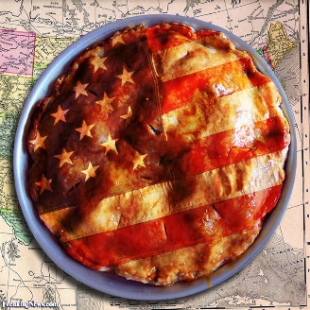1. 9 – 10-inch round PIE

2. Entries must be made from scratch. (Crusts and filling)

3. PIE will be judged on originality, taste and appearance.

4. Recipe must be submitted with entry.

**SECTION VII – VIRGINIA EGG COUNCIL CONTEST**

The Five Star Dessert Bars Recipe Contest sponsored by The Virginia Egg Council judging will be held on Sunday, September 10, 2023 at 4:00 p.m.

Please see additional information and bring with you the entry forms that are available at *https://virginiaeggcouncil.org/events.cfm*

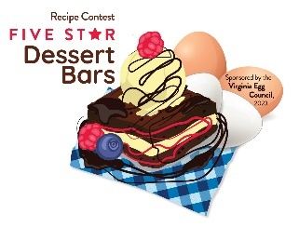

1. The recipe must include a minimum of four large whole eggs.
2. Entrant must prepare a recipe for desert bars, baked in a traditional 9X13” baking pan. *Desert bars should be sliced and presented on a plate or platter for judging.*
3. *Ingredients must be listed in the order of use.*
4. List ingredients in order of use; include clear preparation instructions, cooking time and temperatures, pan size and yield.
5. The legible recipe must be on one side of page and must be submitted with prepared entry
6. Back side of page must include contestant’s name, address, phone and email address and the name of the item.
7. Recipes will be prepared and presented for judging.
8. Contestants must fil in a participant Release Form, to be attached to recipe.

The top three winning recipes get special gifts from the VA Egg Council AND become eligible to compete in the *Five Star Dessert Bars Contest Finals* To be held at the State Fair of Virginia, September 30, 2023

Prizes at STATE Level on September 30, 2023

1st - $400 plus 1 dozen Eggland’s Best Eggs each week for 1 year

2nd - $300 plus 1 dozen Eggland’s Best Eggs a week, for 6 months

3rd - $200 plus 1 dozen Eggland’s Best Eggs a week for six months

**SECTION VIII - CAKES**

PREMIUMS: FIRST - $10.00; SECOND - $7.00; THIRD - $5.00

Standards: Level or slightly rounded and uniform in thickness, light, tender, fine and uniform grain. Slightly moist Icing – smooth texture, good flavor and appropriate for cake. This does not apply to decorated cakes. No mixes.

CLASS

1. Pound or chiffon cake – ½ cake
2. Decorated cakes – Appearance only. Mock forms may be used. Will not cut or taste.
3. 4 cake pops – displayed on form/covered.

**SECTION IX – PIES**

PREMIUMS: FIRST - $10.00; SECOND - $7.00; THIRD - $5.00

CLASS

1. Fruit Pie (For example, fruit, cherry, apple, peach, etc.)

BAZ000092. Fried Pies (same list as above)

3. Tarts

**SECTION X – COOKIES**

PREMIUMS: FIRST - $5.00; SECOND - $3.00; THIRD - $2.00

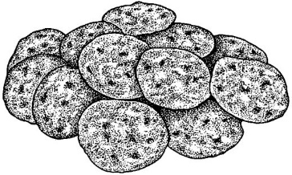CLASS

1. Brownies – three
2. Other Bar Type Cookies – three
3. Dropped Cookies - three
4. Pressed or Shaped – three

**COOKIE JAR CONTEST**

This category is a jar of assorted cookies. Jar may be any kind of wide-mouthed, transparent jar; decorated as desired.

**Premiums** – 1st place - $30, 2nd place - $25, 3rd place $15

**Criteria**

* Jar presentation is 50% of judging
* Cookies will account for 50% of judging
* Jar not less than 6 inches, but no more than 15 inches in height
* 15 inch maximum does not include decorations
* Minimum of three (3) types of cookies
* Cookies must be made by exhibitor
* For judging purposes - One of each cookie must be submitted for judging singularly in a zip-loc baggy, labeled with entry tag on a disposable plate
* Placement awards given at judge’s discretion based on above criteria

**SECTION XI – CANDY**

PREMIUMS: FIRST - $5.00; SECOND - $3.00; THIRD - $2.00

Smooth consistency, free of crystals, characteristics of type.

CLASS

1. Assortment – three varieties, two of each
2. Chocolate fudge – three pieces
3. Peanut butter fudge – three pieces
4. Mints – three pieces
5. Divinity and Sea foam – three pieces
6. Miscellaneous – three pieces

**SECTION XII– CANNED FOODS**

PREMIUMS: FIRST - $5.00; SECOND - $3.00; THIRD - $2.00

CLASS

1. Apple jelly
2. Crabapple jelly
3. Blackberry jelly
4. Grape jelly
5. Raspberry jelly
6. Hot pepper jelly
7. Miscellaneous jelly
8. Peach preserves
9. Strawberry preserves
10. Miscellaneous preserves
11. Blackberry jam
12. Raspberry jam
13. Strawberry jam
14. Miscellaneous jam
15. Apple butter – crock pot
16. Apple butter – long cooked
17. Whole sweet cucumber pickles
18. Cubed sweet cucumber pickles
19. Sliced sweet cucumber pickles
20. Whole sour cucumber pickles
21. Sliced sour cucumber pickles
22. Dill pickles
23. Pickled Peppers
24. Squash or Zucchini pickles
25. Dilly beans or okra
26. Bread and Butter pickles
27. Miscellaneous pickled vegetables
28. Cucumber relish
29. Chow-Chow
30. Pepper relish
31. Miscellaneous relish
32. Pickled beets
33. Sweet potatoes
34. Green beans (cut)
35. Corn
36. Whole tomatoes
37. Stewed tomatoes
38. Tomato juice
39. Tomato sauce
40. October beans
41. Miscellaneous pepper
42. Kraut (jars must be sealed)
43. Soup mixture
44. Miscellaneous vegetables
45. Apples
46. Applesauce
47. Pears
48. Peaches
49. Grape juice
50. Miscellaneous fruit
51. Molasses and syrups
52. Spaghetti Sauce
53. Sauce (Ketchup, Barbeque, hot, etc)
54. Dehydrated fruit or vegetables
55. Salsa
56. 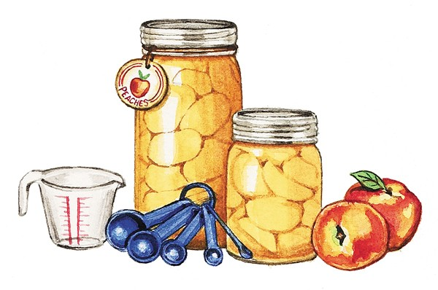Meats
57. Dried herbs