**FARM CROPS**

COMMITTEE: Phil Blevins and Lisa Little

**GENERAL RULES:**

1. All field crops, tobacco, and vegetables must be entered in the name of the producer on **SUNDAY, SEPTEMBER 10, 2023 between the hours of 2:00 p.m. and 5:00 p.m.**
2. Entries must be removed on **SUNDAY, SEPTEMBER 17th between the hours of 1:00 p.m. and 3:00 p.m.**
3. Only one entry per exhibitor in any class and all products must be of the current years’ growth.
4. In any class where there is no competition, a blue ribbon will be awarded (if worth) and second money paid.
5. Any exhibit that deteriorates during the week may be discarded. Premiums will still be awarded and ribbons will be displayed.
6. Any person entering 10 items will be awarded a one-day pass to the Fair. Weekly passes will be given to Best of Show winner in each department.
7. Best of Show winners need to pick up weekly passes at main gate on Monday of the fair.

**DEPARTMENT A FIELD CROPS AND VEGETABLES**

PREMIUMS: FIRST - $5.00; SECOND - $3.00; THIRD - $2.00

SECTION I – OPEN

1. Yellow or White Corn Stalks with ear – 3 stalks
2. Yellow or White Corn – 3 ears (shucked but shuck attached to ear)
3. Popcorn, any variety – 3 ears
4. Ornamental Corn – 3 ears
5. Irish Potatoes – 3 specimens
6. Irish Potato – largest – 1 specimen
7. Sweet Potatoes, 3 specimens
8. Red tomatoes, table type, slicing – 3 specimens
9. 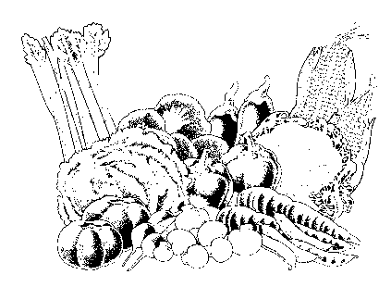Yellow tomatoes, table type, slicing – 3 specimens
10. Small novelty tomatoes – 6 specimens
11. Peppers, sweet bell – 3 specimens
12. Peppers, banana – 3 specimens
13. Peppers, hot – 3 specimens
14. Green Beans, snap – 6 specimens
15. Pole Beans – 6 specimens
16. October Beans – 1 pint
17. Beets with tops – 3 specimens
18. Broccoli – 1 bunch
19. Carrots, with tops – 3 specimens
20. Chicken Eggs (1 dozen in carton)
21. Chestnuts – 5 specimens
22. Sweet Corn, untrimmed, in shuck – 3 ears
23. Cucumber, slicing – 3 specimens
24. Cucumber, pickling – 3 specimens
25. Yellow onion – 3 specimens
26. BSA00080Red Onions – 3 specimens
27. White Onions – 3 specimens
28. Pumpkin, any variety, good quality – 1 specimen
29. Pumpkin, largest – 1 specimen
30. Pumpkins, Jack-O-Lantern Type – 1 specimen
31. Squash, any variety, good quality – 1specimen
32. Gourd, ornamental display – 3 or more
33. Gourd, large type – 1 specimen
34. Okra – 3 pods
35. Squash, winter type – 1 specimen
36. Summer squash – 3 specimens
37. Grapes – 3 bunches
38. Sunflower, good quality, 1 head
39. Vegetable plate, exhibitor’s choice – 5 or more specimens
40. Watermelon – 1 specimen
41. Cantaloupe – 1 specimen
42. Honey with comb
43. Honey strained
44. Miscellaneous
45. Hay, alfalfa – 1 bat in clear plastic bag
46. Hay, orchard grass – 1 bat in clear plastic bag
47. Hay, Timothy – 1 bat in clear plastic bag
48. Hay, mixed grass – 1 bat in clear plastic bag

SECTION II – YOUTH

Classes same as above for youth under 18 as of day of show.

PREMIUMS (to be paid in addition to ribbons):

FIRST - $5.00; SECOND - $3.00; THIRD - $1.00

**DEPARTMENT B BURLEY TOBACCO**

PREMIUMS (to be paid in addition to ribbons):

FIRST - $25.00; SECOND - $15.00; THIRD - $10.00; FOURTH - $5.00



CLASS

1. Stalks, 3 green, 2022 crop – Fresh cut