YOUTH ARTS AND CRAFTS

**SCHEDULE**

**ENTRY DATE: Sunday, September 11, 2022; 2:00 p.m. – 6:00 p.m.**

**JUDGING: Monday, September 12, 2022; 9:00 a.m. – 2:00 p.m.**

# CHECK OUT FOR ALL ITEMS: Sunday, September 18, 2022;

**1:00 p.m. – 3:00 p.m.**

**Youth Committee:** Hannah Barker, Katie Terry, Kaylee Arney,

Kendall Sullins, Kate Belcher, Kelli Garrett, Noah Smith,

Laken Minnick, Ashli Linkous, Mckenzie Wise

Burgin Peek and Caitlyn Horton

## YOUTH

## EXHIBITORS

# Ages: 5 to 19 years old

**YOUTH GENERAL RULES:**

1. Exhibits must be made or grown by each individual exhibitor.
2. Exhibits must have been made after September 2021.
3. Exhibitor will be able to make only one entry per class.
4. Food items must be displayed on disposable plates in re-closeable clear plastic bag.
5. Awards may be withheld from any entry not worthy in the opinion of all the judges. We reserve the right to refuse items that are not “fair quality”.
6. All decisions of the judges are final.
7. Committee will not be responsible for items not picked up at the designated check-out time.
8. Every possible care will be taken to protect items; however, the committee assumes no responsibility in case of loss or damage to exhibits. Only under these conditions are entries received.
9. Any youth entering 10 items will be awarded a one-day pass to the Fair.
10. Classes specifically for Youth shall be divided as follows:

Young Explorers - 5-8 years old; Jr. Division – 9 to13 years old;

Sr. Division – 14 to 19 years old.

11. “Best of Show” Award will be given to entries deemed best overall in the following areas: Crafts, Youth Horticulture, Foods, and Clothing. Best of show may be awarded to any youth ages 5 to 19. Youth awarded this honor will receive an additional premium of $5.00 and a weekly pass to the fair.

### 12. Best of Show winners need to pick up weekly passes at the main

gate on Monday of the fair.

### DEPARTMENT A HOUSING

PREMIUMS: FIRST - $5.00; SECOND - 3.00; THIRD - $2.00

### SECTION I – CRAFTS (Ages: 5 to 19 years old)

### CLASS

1. Room Improvement Article (no pillows)
2. Door Decoration
3. Art – Paintings (must be matted, no larger than 11x14)
4. Art - Crayons (coloring page only; no bigger than 8.5x11) (YE only)
5. Art - Pencil Drawing (#2 pencil or colored, no bigger than 8.5 x 11)
6. Photography (1 photograph; matting only, no frame, 4x6 to 8 x 10)
7. Collage (no larger than 11x14)
8. Canvas Painting – Unframed of any size.
9. Tin Punch
10. Jewelry - Earrings
11. AVA00006Jewelry - Bracelets
12. Jewelry – Necklaces
13. Jewelry - Rings
14. Embroidery
15. Quilts & Quilted Items
16. Ceramic Items
17. Christmas Decoration
18. Counted Cross Stitch
19. Bead Art (no jewelry pieces)
20. Model (any kind)
21. Lego Art (must have theme & must be secured on board no bigger than 11 x 14)
22. Hobby Collections (must be in a container)
23. Woodworking (i.e. birdhouses, feeders, etc./woodcarving) 12 inches & smaller
24. Woodworking (i.e. birdhouses, feeders, etc./woodcarving) Larger than 12 inches
25. Something from Nothing (with description on index card)
26. Recycled Item (with description on index card)
27. Sew and Show pillows.
28. Pillowcases – Hand or Machine sewn
29. Purses
30. Leathercraft
31. Decorated Pumpkin (no carving or cutting; faces only)
32. Sand Art
33. MC900089032[1]Hair Accessory
34. Duct Tape Craft Item
35. Decorated Flip Flops
36. String Art
37. Mosaics
38. Miscellaneous

### SECTION II – YOUTH HORTICULTURE

PREMIUMS: FIRST - $5.00; SECOND - $3.00; THIRD - $2.00

### RULES

1. General rules apply to this section.
2. Plastic drink bottles (not glass) no larger than 16oz.
3. 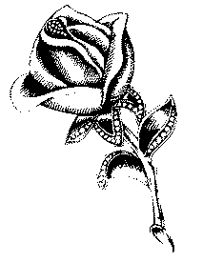No class age division.

CLASS

1. Zinnias
2. Marigolds
3. Dahlias
4. Celosia
5. Petunia
6. Roses – miniature
7. Roses - Standard
8. Asters
9. Potted Geranium

10. Dish Garden

11. Flowering potted plant – 8”-12”

12. Hanging Basket, flowering

13. Potted Collection must have at least two varieties

14. Theme Arrangement:”Celebrating the Beauty & Bounty of Washington County”

15. Potted Fairy Garden

### DEPARTMENT B FOODS

1. Items must be exhibited on paper plates in re-closeable clear plastic bag.
2. Young Explorer, Junior, and Senior Division for all classes.
3. No food items are to be made from commercial mix.
4. Recipes must be submitted on index card with entry.

PREMIUMS: FIRST - $5.00; SECOND - $3.00; THIRD - $2.00

### SECTION I – BREADS

### CLASS

1. 3 biscuits
2. 3 fruit muffins
3. Skillet Corn Bread (3 wedges)
4. ½ Yeast Loaf Bread
5. 3 slices Quick Bread

### SECTION II – COOKIES CAKES & PIES

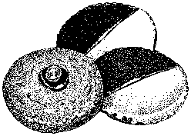**CLASS**

1. 3 Chocolate Chip Cookies

2. 3 Peanut Butter Cookies

3. 3 Sugar Cookies

4. 3 Oatmeal Cookies

5 3 No Bake Cookies

6 3 Brownies

7. 3 slices cake or 3 cup cakes – cook’s choice

8. 3 slices/pieces cooks choice gluten free cake or brownie

9. Decorated Cakes – Judged on appearance only (mock forms only)

10. 3 decorated cupcakes

11. 4 Cake Pops - presented on Styrofoam form/covered.

12. Whole Pie – Non-Refrigerated variety.

13. 3 Cookie dessert bars of choice

**SECTION III – CANDY**

**CLASS**

1. 3 pieces of Chocolate Fudge
2. 3 pieces of Peanut Butter Fudge
3. Miscellaneous (cook’s choice – 3 pieces)

**SECTION IV – CANNED FOODS**

1. Entries must be in standard canning jars and lids, rings must be on jar.
2. Young Explorers, Junior and Senior Division for each fruit or vegetable.
3. All entries must have been canned by the exhibitor since October, 2021.
4. No rust on lids or rims.
5. Please put entry card with item(s) canned.

**CLASS**

1. 1 quart or 1-pint fruit
2. 1 quart or 1-pint tomatoes (no juice)
3. 1 quart or 1-pint green beans
4. 1 quart or 1-pint sweet pickles
5. 1 quart or 1-pint dill type pickles.
6. 1 pint or ½ pint jelly (no apple butter)
7. 1 pint or ½ pint jam (no apple butter)
8. 1 pint or ½ pint apple butter

9. 1 pint or ½ pint Salsa

10. 1 pint or ½ pint miscellaneous

**DEPARTMENT C CLOTHING**1. Items must be secured on hangers.

2. General Rules apply to this section.

PREMIUMS: FIRST - $5.00; SECOND - $3.00; THIRD - $2.00

**CLASS**

1. AUY00011Apron
2. Vest
3. Shorts
4. Slacks
5. Blouse or Shirt
6. Skirt
7. Dress of choice
8. Jacket
9. Child’s or Baby’s Garment
10. Wool Garment (70% Wool)
11. Painted T-Shirt
12. Tie-dye Shirts
13. Crocheted or Knitted Article (example: Vest, Sweater, Scarf, etc.)
14. Appliqued Design Garment, Example: Heat Press (no purses)
15. Doll Cloths
16. Clothing Item made from alternative materials (example: duct tape or newspaper)
17. Themed Outfit (Shirt & Shorts/Pants) To illustrate theme

and can be a decade or fair theme.

**FARM CROPS**

COMMITTEE: Phil Blevins and Lisa Little

**GENERAL RULES:**

1. All field crops, tobacco, and vegetables must be entered in the name of the producer on **SUNDAY, SEPTEMBER 11, 2022 between the hours of 2:00 p.m. and 6:00 p.m.**
2. Entries must be removed on **SUNDAY, SEPTEMBER 18th between the hours of 1:00 p.m. and 3:00 p.m.**
3. Only one entry per exhibitor in any class and all products must be of the current years’ growth.
4. In any class where there is no competition, a blue ribbon will be awarded (if worth) and second money paid.
5. Any exhibit that deteriorates during the week may be discarded. Premiums will still be awarded and ribbons will be displayed.
6. Any person entering 10 items will be awarded a one-day pass to the Fair. Weekly passes will be given to Best of Show winner in each department.
7. Best of Show winners need to pick up weekly passes at main gate on Monday of the fair.

**DEPARTMENT A FIELD CROPS AND VEGETABLES**

PREMIUMS: FIRST - $5.00; SECOND - $3.00; THIRD - $2.00

SECTION I – OPEN

1. Yellow or White Corn Stalks with ear – 3 stalks
2. Yellow or White Corn – 3 ears (shucked but shuck attached to ear)
3. Popcorn, any variety – 3 ears
4. Ornamental Corn – 3 ears
5. Irish Potatoes – 3 specimens
6. Irish Potato – largest – 1 specimen
7. Sweet Potatoes, 3 specimens
8. Red tomatoes, table type, slicing – 3 specimens
9. Yellow tomatoes, table type, slicing – 3 specimens
10. 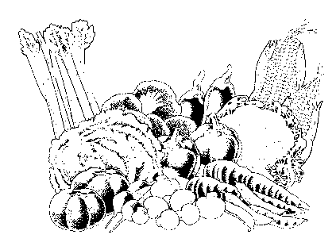Small novelty tomatoes – 6 specimens
11. Peppers, sweet bell – 3 specimens
12. Peppers, banana – 3 specimens
13. Peppers, hot – 3 specimens
14. Green Beans, snap – 6 specimens
15. Pole Beans – 6 specimens
16. October Beans – 1 pint
17. Beets with tops – 3 specimens
18. Broccoli – 1 bunch
19. Carrots, with tops – 3 specimens
20. Chicken Eggs (1 dozen in carton)
21. Chestnuts – 5 specimens
22. Sweet Corn, untrimmed, in shuck – 3 ears
23. Cucumber, slicing – 3 specimens
24. Cucumber, pickling – 3 specimens
25. Yellow onion – 3 specimens
26. Red Onions – 3 specimens
27. White Onions – 3 specimens
28. Pumpkin, any variety, good quality – 1 specimen
29. Pumpkin, largest – 1 specimen
30. BSA00080Pumpkins, Jack-O-Lantern Type – 1 specimen
31. Squash, any variety, good quality – 1specimen
32. Gourd, ornamental display – 3 or more
33. Gourd, large type – 1 specimen
34. Okra – 3 pods
35. Squash, winter type – 1 specimen
36. Summer squash – 3 specimens
37. Grapes – 3 bunches
38. Sunflower, good quality, 1 head
39. Vegetable plate, exhibitor’s choice – 5 or more specimens
40. Watermelon – 1 specimen
41. Cantaloupe – 1 specimen
42. Honey with comb
43. Honey strained
44. Miscellaneous
45. Hay, alfalfa – 1 bat in clear plastic bag
46. Hay, orchard grass – 1 bat in clear plastic bag
47. Hay, Timothy – 1 bat in clear plastic bag
48. Hay, mixed grass – 1 bat in clear plastic bag

SECTION II – YOUTH

Classes same as above for youth under 18 as of day of show.

PREMIUMS (to be paid in addition to ribbons):

FIRST - $5.00; SECOND - $3.00; THIRD - $2.00

**DEPARTMENT B BURLEY TOBACCO**

PREMIUMS (to be paid in addition to ribbons):

FIRST - $25.00; SECOND - $15.00; THIRD - $10.00; FOURTH - $5.00



CLASS

1. Stalks, 3 green, 2021 crop – Fresh cut

**2022 HONEY SHOW**

**PRESENTED BY**

**THE HIGHLANDS BEEKEEPERS ASSOCIATION**

SHOW CHAIRPERSON: Jeremy Blackwell: abingdonbeecompany@gmail.com

CHECK-IN TIME: Sunday, September 11, 2022; Between 2:00 PM and 6:00 PM.

PICKUP TIME: All entries will remain in the show area for public viewing after the judging. All entries will remain on display. Exhibitors may pick up their entries on Sunday, September 18th, between 1:00 PM and 3:00 PM. Entries not picked up by 3:00 PM on Sunday, September 18th, will be disposed of by the Honey Show Committee.

**General Rules of the Honey Show**:

1. The honey show is open to any attendee who wishes to enter one or more exhibits, except as otherwise specifically provided for herein. The honey show is NOT open to individuals serving as Judges, Show Chairman, or Show Secretary.
2. Entries must be received between 2:00 PM and 6:00 PM on Sunday, September 11, 2022. No entries will be accepted after this deadline.
3. Each Exhibitor must sign an affidavit stating that each entry he or she submits was produced by the Exhibitor in conformity with the rules set forth herein.
4. Each Exhibitor may make only one entry per class. Duplication (same product) of entries by families is also prohibited.
5. All exhibits must be produced by the Exhibitor within the last calendar year.
6. In instances where the exhibit may qualify for consideration in multiple classes, the Exhibitor shall have the final decision as to which class to enter the exhibit.  This selection will not be overturned by the Judge(s). Said exhibit will be judged based on the criteria set forth in the selected class.
7. Once exhibits have been accepted into the competition by the Show Secretary, they may not be altered in any way.
8. After submitting entries to the Show Secretary, Exhibitors may not enter the area where the exhibits have been placed.
9. The Secretary, Stewards or Judges are the only persons who may enter the honey judging area.
10. Judges will enter the honey show area after the close of Exhibitor acceptance. This is to ensure as close to a blind judging as possible.
11. Allowances will be made for minor damage to cappings in entries in the comb honey categories, where such minor damage is clearly the result of previous judging in another show.
12. For all exhibits which require, or give the Exhibitor the option of using, any display case, dish, base, frame, stand, or any other exhibition aide, the same should be presented in the same clean, neat, and uniform manner so as to complement and add merit to the accompanying exhibit.
13. Entries for winners in each class & Best in Show will be held for display at the Southwest Virginia Cultural Center & Marketplace. Entrant’s will be notified when the display has been removed and coordinate a pickup day/time.
14. Exhibits and other items not retrieved by the deadline posted for pick-up, shall be deemed abandoned, and shall be donated to the Highlands Beekeepers Association Honey Show Committee for future use or disposal. The Highlands Beekeepers Association is not responsible for any items left after the pick-up deadline.
15. Copyright of any submitted recipe, artwork, literary work, or other media remains with the Exhibitor, but the Highlands Beekeepers Association has the unrestricted right to publish images of submitted recipe, artwork, literary work, or other media in its newsletter, on its website, and via its social media outlets, plus unrestricted rights to use the same in any related material for PR purposes.

**Prizes & Awards**:

It is the intention that ribbons will be given in all classes even if there is only one entry in the class. However, in order to receive an award that entry must be worthy of placement. Entry into a class does not guarantee an award. The decisions of the Judges are final. Exhibitors found willfully cheating, or purposefully altering or disfiguring an entry for the purpose of influencing the validity of judging will be disqualified from the contest, as well as from any future honey shows sponsored by the Highlands Beekeepers Association for a period of not less than three (3) years. Ribbons will be awarded to Best in Show, First, Second and Third place winners in each class. Cash prizes will be awarded to Best in Show & First place winners in each class. Gift baskets or similar prizes will be awarded to Second and Third place winners in each class. Entries for winners in each class & Best in Show will be held for display at the Southwest Virginia Cultural Center & Marketplace.

**Awards for the Fall Honey Show are as follows**:

* Best in Show - $75

**Classes**:

* First place - $50
* Second Place - Gift Basket or Equivalent
* Third Place - Gift Basket or Equivalent

**Classes:**

The following categories will be accepted and judged at the Honey Show:

Class 1: Extracted Honey

A. Light

B. Amber

C. Dark

D. Youth

Cloverbud (ages: 5-8)

Junior (ages: 9-13)

Senior (ages: 14 - 17)

Class 2: Chunk Honey Comb

Class 3: Full Frame Comb Honey

Class 4: Beeswax Block

**Rules for Individual Classes:**

**Class 1: Extracted Honey**

Extracted honey is judged in three subclasses for Adults as well as Youth classes: (a) light, (b) medium or amber, and (c) dark. (d) Youth will be divided into Cloverbud (5-8), Junior (9-13) and Senior (14-17). Youth may be further subdivided into Light, Amber, & Dark classes, depending on the number of entries. Entrants may submit one entry in each of these three classes. One entry of extracted honey is defined as two (2) one-pound jars. All forms of extracted honey are to be presented in one-pound, glass (no plastic), “Queen-line” or “Classic” style jars. Closures may be of metal or plastic. Tamper-proof seals are prohibited. There shall be no labels on the jars. Judges evaluate entries on the following: Cleanliness of the jar and lid; Correct fill level; Uniformity of the two jars that comprise the entry; Cleanliness and clarity of the honey; Moisture content; and aroma and flavor (for off aromas and or flavors). Contact Jeremy @ Abingon Bee Company 276-492-5369 if you need to purchase jars at cost for the competition.

**Class 2: Chunk Comb Honey**

One entry of chunk honey is defined as two (2) 1-pound jars. Chunk honey must be displayed in straight sided, glass, wide mouth, jars. The glass should not be embossed. Only one chunk of comb should be in each jar for competition. The chunk of comb must be in one piece, with a straight mid rib and of uniform thickness. The cuts should be clean and uniform. The chunk comb should be cut and sized to appropriately fit the container. Honey should fill the rest of the jar to the appropriate fill line. The comb should be oriented in the container as found naturally in the hive. Comb with watery cappings should be avoided. The comb should extend the length of the jar. Comb is judged for equal amounts on either side of the center rib. The criteria stated above for judging extracted honey applies to judging chunk honey as well. Contact Jeremy @ Abingdon Bee Company 276-492-5369 if you need to purchase jars at cost for the competition.

**Class 3: Full Frame Comb Honey**

An entry of full frame comb honey is one (1) frame of capped honey suitable for radial or tangential mechanical extraction. Frames must be shown in protective casing without lacing or edging and both sides of the comb should be visible. Judging criteria are completeness of capping, uniformity of appearance and color (including the honey in the comb), cleanliness, absence of uncapped or leaking cells, no “wet” cell appearance, freedom from granulation and pollen, and symmetry throughout the frame. Total weight of the entire entry may be used as a tiebreaker. Contact Jeremy @ Abingdon Bee Company 276-492-5369 for assistance with shrink wrapping your entry.

**Class 4: Beeswax Block**

An entry consists of one (1) block of pure beeswax. The block must weigh between one to two pounds, no more, and should have thickness no greater than 1.5 inches. The wax should be clean, and free of impurities. The block should be smooth-surfaced and free of blemishes, decorations or embellishments. Preferable color should be lemon yellow with a pleasant fragrance. The block should be submitted on a plain, white paper plate, in a zip-top bag. Alternatively, at the Exhibitor’s option, the block may be shown in a protective display case. If a showcase is used, it must not exceed 12”(length) x12”(width) x4”(depth), and the wax block must be readily accessible for judging. The show case will not be judged.

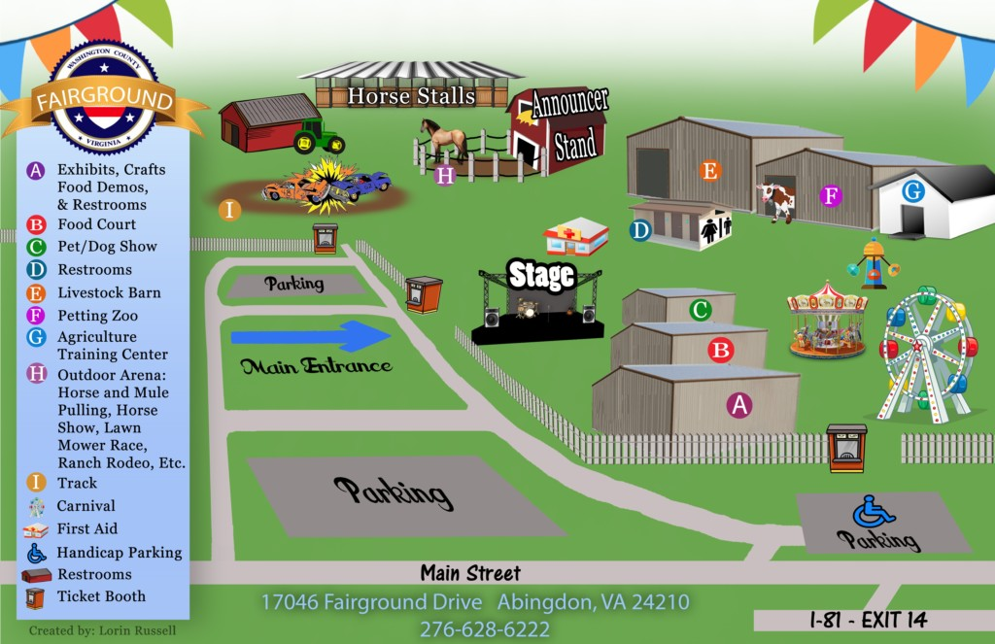

**Washington County Fairgrounds**

1. **Exhibits, Crafts, Food, Restrooms, Food Demos**
2. **Food Court**
3. **Chili Cook-Off, Dog Show**

**Outside Stage – Main & Local Entertainment**

**First Aid**

1. **Restrooms**
2. **Livestock Shows, Herding Dog Demonstrations**
3. **Petting Zoo**
4. **Agriculture Training Center**
5. **Carnival**
6. **Horse & Mule Pulling, Horse Shows, Lawn Mower Race, Power Sports, Rodeo, Demolition Derby**

**Daily Admission**

**Monday through Saturday Weekly Pass**

Adults $15.00 Sold Until September 1st. Ages 12 and under Free $50.00

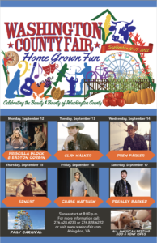

**SCHEDULE OF EVENTS**

**Sunday, September 11th**

2:00 p.m.-6:00 p.m. Enter **Youth** arts, crafts, clothing, foods, canned foods,

flowers and educational exhibits (A)

2:00 p.m.-6:00 p.m. Enter **Adult & Youth** farm crops and tobacco (A)

2;00 p.m.-6:00 p.m. Enter Adult & Youth Honey Show

2:00 p.m.-6:00 p.m. Enter **Adult** canned foods, foods, crafts, potted plants,

flowers, and educational exhibits (A)

**Monday, September 12th**

4:00 p.m. GRAND OPENING OF FAIR

5:30 p.m. Appalachian Craft Corner – Pinch Pot Pottery

6:00 p.m. Carnival Opens (H)

6:00 p.m. 4-H Market Hog Show (E)

6:00 p.m. All-American Petting Zoo & Pony Rides

6:00 p.m. Antique Tractor Pull

6:30 p.m. Pageants (A)

8:00 p.m. PRISCILLA BLOCK & EASTON CORBIN - (OS) – Sponsored by **WXBQ**

*\*Unlimited Carnival Rides - $18.00 per Person*

*6:00 p.m. – 10:00 p.m.\**

**Tuesday, September 13th**

10:00 a.m.- 2:00 p.m. Senior Citizen’s Day (Free Admission)

10:00 a.m. All-American Petting Zoo % Pony Rides

11:00 a.m. Entertainment

1:30 p.m. Door Prize Drawing

4:00 p.m. DOORS OPEN

5:30 p.m. Appalachian Craft Corner – Barn Quilt Squares

6:00 p.m. All-American Petting Zoo and Pony Rides

6:00 p.m. Carnival Opens (H)

6:00 p.m. Appalachian Area Small Animal Show

6:30 p.m. Bingo (A)

8:00 p.m. CLAY WALKER (OS)

*Unlimited Carnival Rides - $30.00 per person 6:00 p.m. - 10:00 p.m.*

10:00 p.m. to closing per ticket price

**Wednesday, September 14th**

9:30 a.m. Pre-School and Kindergarten Tours

10:00 a.m. All-American Petting Zoo & Pony Rides

4:00 p.m. DOORS OPEN

5:00 p.m. Virginia Egg Council

5:30 p.m. Appalachian Craft Corner – Woodblock Printing

6:00 p.m. All-American Petting Zoo & Pony Rides

6:00 p.m. Carnival Opens (H)

6:00 p.m. Rodeo & Bull Riding

8:00 p.m. DREW PARKER (OS)

*Unlimited Carnival Rides - $30.00 per person 6:00 p.m. - 10:00 p.m.*

10:00 p.m. to closing per ticket price

**Thursday, September 15th**

9:30 a.m. Pre-School & Kindergarten Tours

4:00 p.m. Doors Open – Free Admission for Veterans, Military & First Responders with proper ID

5:00 p.m. 4-H Youth Poultry Show Registration (E)

5:30 p.m. Appalachian Craft Corner – Pulled String Painting

6:00 p.m. 4-H Youth Poultry Show (E)

6:00 p.m. Carnival Opens (H)

6:00 p.m. All-American Petting Zoo and Pony Rides

6:00 p.m. Dairy Night Food Event (A)

6:00 p.m. Rodeo & Bull Riding

6:30 p.m. Mullet & Beard Contest

8:00 p.m. 4-H Poultry Auction (E) **Buyers Welcome**

**8:00 p.m. ERNEST (OS)**

*Unlimited Carnival Rides - $30.00 per person 6:00 p.m. - 10:00 p.m.*

10:00 p.m. to closing per ticket price

**Friday, September 16th**

12:00 noon Doors Open

12:00 p.m. – 3:00 p.m. School Day (Free Admission until 3:00 p.m.) (Student/School Employees)

Adults $5.00 (12:00 - 3:00 p.m.)

12:00 p.m. Carnival Opens (H)

12:00 p.m. All-American Petting Zoo & Pony Rides

3:00 p.m. School Day Talent Show (A)

4:00 p.m. Beef Cattle Show (E)

6:30 p.m. Horse Pulling Contest

8:00 p.m. CHASE MATTHEW (OS) Sponsored by Alpha Natural Resources

*Unlimited Carnival Rides - $30.00 per person – 1:00 p.m. – 6:00 p.m.*

6:00 p.m. to closing per ticket price

**Saturday, September 17th**

9:00 a,m. Open Horse Show (H)

11:30 a.m. Junior Market Goat Show, Lamb Show, Junior Ewe Lamb Show (E)

12:00 noon Doors Open

12:00 noon All-American Petting Zoo & Pony Rides

12:00 noon Pet Show (C)

3:00 p.m. Apple Pie Baking Contest Judging (A)

6:00 p.m. – 8:00 p.m.. Square Dancing

8:00 p.m. PRESLEY BARKER (OS) Sponsored by **Highlands Union Bank**

*Unlimited Carnival Rides - $30.00 per person - 1:00 p.m. - 6:00 p.m.*

6:00 p.m. to closing per ticket price

**Sunday, September 19th**

1:00 p.m.-3:00 p.m. Check Out All Exhibits (A)

**Please refer to inside of back cover for map of the fairgrounds.**

**FAIR DIRECTORS**

Roger Garrett, Debbie Icenhour, Janet Lester, Jennifer Berry-Blankenship,

Kevin Thayer, Kristen White, Laura Boardwine, Mike Overstreet, Phil McCall,

Todd Reynolds, Natalie Blevins, Shauna Reynolds, Nick Belcher, Jessica Tilson, Michelle Woods, Carl Wells & Kate Belcher

**WE SALUTE OUR SPONSORS**

**WXBQ**

**Highlands Union Bank**

**National Bank**

**Pioneer Chevrolet**

**Washington County Farm Bureau**

**Johnson Memorial Hospital**

**Eastman Credit Union**

**Empire Ford**

**Food City**

**Kroger**

**New Peoples Bank**

**Farris Funeral Home**

**First Bank & Trust**

**Farm Credit**

**Berry Iron & Metal Company**

**Wells Fargo**

**Wholesale Vinyl & Aluminum, Inc.**

**Michael’s Pharmacy**

**Southfork Realty**

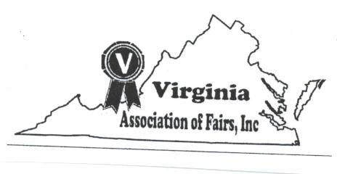

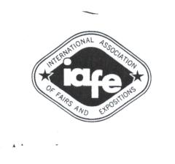

**ADULT HOME ECONOMICS DEPARTMENT**

**(Ages 19 and Older)**

**CHECK IN TIME: All exhibits will be checked in Sunday, September 11th 2:00 p.m. - 6:00 p.m.**

**JUDGING TIME: Monday, September 12th, 10:00 a.m. - 2:00 p.m.**

**CHECK OUT TIME FOR ALL ITEMS: Sunday, September 18th, 1:00 p.m. - 3:00 p.m.**

**General Rules**

**PLEASE NOTE CHANGES THROUGHOUT THIS DEPARTMENT!**

1. Exhibitors will be allowed to make only one entry per class.
2. Entries must be made in the name of the person doing the work.
3. Items must have been made in the past two years.
4. No blue ribbon winners in previous Fairs may be entered.
5. Every possible care will be taken to protect items; however, the committee assumes no responsibility in case of loss or damage to exhibits. Only under these conditions are entries received.
6. Items deemed soiled or otherwise not acceptable by the department committee may be refused. Items must be in new or "like new" condition.
7. Awards will be given only as the judges consider them worthy. Judges decision will be final.
8. Committee will not be responsible for items not picked up at the designated check-out time.
9. Definition of Kit – a creative collection of materials prepared by a person or company, etc. which contains necessities to complete a project by them and made into a kit.
10. Awards will be given to the FCE club with the largest number of creditable exhibits. FIRST - $15.00; SECOND - $10.00; THIRD - $8.00. Score system used: Blue ribbon – 5; Red Ribbon – 4; White Ribbon – 3; Entry – 1. These awards are sponsored by the Washington County FCE Clubs. Club name must be noted upon entry with fair officials for credit to be given.
11. Any person entering 10 items in the Adult Home Economics Department will be awarded a one-day pass to the Fair. Weekly passes will be given to Best of Show winner in each department.
12. Entry tags are available at the fairgrounds during Sunday registration only. For your convenience and to save time, it is permissible to use pre-printed address labels when filing out your entry tags.
13. No entries will be accepted from anyone under the age of 19.
14. Best of Show winners need to pick up weekly passes at main gate on Monday of the fair.

**DEPARTMENT A CRAFTS**

PREMIUM: FIRST - $5.00; SECOND - $3.00; THIRD - $2.00

All general rules and regulations will apply regarding entries.

**PLEASE NOTE CHANGES THROUGHOUT THIS DEPARTMENT**

CLASS

1. Pieced bed quilt (non-long arm quilted) **
2. Pieced bed quilt (long arm machine quilted) **
3. Cotton pieced bed quilt (must be hand quilted) **
4. Appliqué bed quilt (appliqué must be dominant technique) **
5. Novelty bed quilt I (embroidery, cathedral window cross-stitch) **
6. Novelty bed quilt II (tied/tacked, textile painted, pre-printed, T-shirt, yo-yo)**
7. Small bed quilt (throws, lap, crib)**
8. Quilted Bed Runner (no table runners)
9. Miscellaneous bed quilt (any bed quilt item not included above)
10. Quilted wall hanging (24” or under on all sides)
11. Quilted wall hanging (over 24” on any side)
12. Non-traditional quilted wall hanging (pictorial, painted, beaded)
13. Quilted household articles (table runners, place mats)
14. Quilted garments/accessories (not including tote bags)
15. Quilted tote bags
16. Quilted purses
17. Covered Clothesline (fabric bowls and fabric articles)
18. Crocheted baby afghans
19. AUQ00006Crocheted afghans - other
20. Adult crocheted garments
21. Baby crocheted garments
22. Crochet article other
23. Adult knitted items
24. Child’s knitted items
25. Knitted afghan
26. Felted article
27. Needlepoint article
28. Needlepoint on plastic
29. Embroidery Article
30. Counted cross stitch – other items (no pillows)
31. Stitchery from kit other than those listed
32. Aprons
33. Sewed items – garments
34. Sewed dolls and toys
35. Sewed doll cloths
36. Sewed item – children’s garment
37. Sewed items – non-garments
38. Painted fabric garments
39. Appliqued’ garments
40. Pillow – Cross stitch
41. Pillows – Others
42. Fiber Weaving (no baskets)
43. Rugs – 4 square foot or smaller
44. Ceramic article – free form (shaped by hand)
45. Ceramic article – form mold
46. Handmade jewelry
47. Decorated Pumpkin – no carving or cutting – (faces only)
48. Decorated Pumpkin – no carving or cutting – design (no faces)
49. Duct Tape Craft Item
50. Repurposed Item
51. Something from nothing (utilitarian)
52. 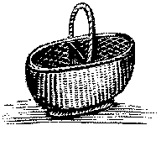Something from nothing (ornate)
53. Baskets – hand woven (cane, reed, white oak)
54. Baskets – decorated
55. Room Improvement Décor.
56. Woodworking – small
57. Woodworking – larger – not to exceed size of chair or small chest
58. Wood carving six inches and smaller.
59. Woodworking Bowls
60. Wood carving larger than six inches.
61. Bead work – purses and accessories
62. Decorated Flip Flops
63. Christmas Decorations
64. Christmas Ornaments (must include hook)
65. Hair Accessories.
66. Holiday Wreaths/Door Décor.*
67. Wreath/Door Décor.*
68. Painted Quilt Square 2ft x 2ft (Similar to Barn quilt square)*
69. Framed pictures – cross stitch (not to exceed 18 X 20 including frame)*
70. Framed pictures – oil, acrylic, water color*
71. Framed pictures – pencil charcoal.*
72. Stained glass – no to exceed 24” x 48” in size*
73. Miscellaneous – any item not included above – duplicates of above

Categories will not be accepted.

1. Photography – color (must be framed)*
2. Photography – Black and White (must be framed)*
3. Photography – Digitally altered/enhanced (must be framed) -

(Small copy of original must be attached to back)*

*Entries in class 66 thru 76 must be prepared for hanging.

** Bed quilt may be twin size or larger.

THEMED TABLE SETTING

1. Themed Table Setting (One place setting 24” X 30”)

* Additional Premium First $10.00, Second $7.00, Third $5.00
* Theme must be clearly defined through presentation and title

**DEPARTMENT B FOODS**

PREMIUMS: FIRST - $5.00; SECOND - $3.00; THIRD - $2.00

**RULES**

1. Baked goods must be displayed on rigid disposable plates and covered with clear re-sealable plastic bag.
2. All canned products and pickles must be in clear glass **regulation canning jars and properly sealed.** Canned products not in regulation jars (i.e. mayonnaise, peanut butter, pickle, etc.) will not be accepted. No paraffin on jelly.
3. Jellies, jams, preserves and pickles may be opened for judging.
4. Rings must be on jars.
5. General Rules and Regulations apply.
6. The Ball Blue Book recommendations will be used as the criteria when determining if a product is accepted for judging.
7. Baked goods that become visually unattractive will be discarded.
8. No canned foods will be accepted with rust on lids or rings.
9. Canned products not sealed will not be accepted for entry.
10. Canned foods judged on appearance only. Judges will not taste canned

foods.

**SECTION I – BREADS**

PREMIUMS: FIRST - $4.00; SECOND - $3.00; THIRD - $2.00

Standards

LOOKS: tender and good, even, golden brown color, good shape

TEXTURE: fine, even grain, small thin cell walls, light for size, crisp crust

CRUMB: creamy white, slightly moist, light and elastic, tender

FLAVOR: good, well-blended flavor, pleasing

CLASS

1. Three rolls
2. Light loaf bread (½ loaf)
3. Quick sweet bread (½ loaf or whole small loaf)
4. Yeast sweet bread (½ loaf or 3 rolls)
5. Three biscuits
6. Cornbread – two pieces
7. Cornbread – muffins or sticks (2)
8. Muffins (2)
9. Sourdough (½ loaf)
10. Scones
11. Anything made from canned biscuits

**SECTION II – SPECIAL BREAD CATEGORY (½ LOAF)**

FIRST - $15.00; SECOND - $10.00; THIRD - $7.00

All entries in this category must be made from the following recipe contributed by Mrs. Kenton Chittum.

2 tablespoons shortening 1 cup scalded milk

1 cup boiling water 1 yeast cake softened in

2 tablespoons sugar ¼ cup lukewarm water

2 teaspoons salt 6 to 6½ cups all-purpose bread flour

Put shortening, sugar and salt in a large bowl without a lid, or in top of large double broiler. Add liquids. Cool to lukewarm. Add yeast. Stir in 3 cups of flour. Mix thoroughly. Add 2 cups of flour, mix and add remaining flour gradually, using just enough to prevent sticking to the bowl.

Put the last ½ cup of flour on the mixing board or cloth and use some of it to dust the board very lightly, pushing the rest aside to work into the dough, if you need it. Turn the ball of dough out onto the board, leaving a clean bowl. Cover and let “rest” 10 minutes, which makes the dough easier to work with.

Knead, let rise, punch down and shape. Let rise until double in bulk (about one hour) and bake. Bake at 375° for 15 minutes and lower oven temperature to 350° and continue baking for 25 to 30 minutes. Your loaf should have a hollow sound when “plunked” on the top.

**SECTION III – SPECIAL CAKES (½ Cake)**

PREMIUM: FIRST - $15.00; SECOND - $10.00; THIRD - $7.00

1. All entries in this category must be made from a Spice cake mix.
2. It may be changed any way desired by cook other than the quantity.
3. Cake will be judged on originality, taste, and appearance. Any frosting or filling may be included.
4. Recipe must be submitted with entry.

**SECTION IV – THEME CAKE – “MY HOME TOWN”**

Create a cake that represents our home towns, such as our green pastures, the Creeper Trail, or our historic Wolf HIlls

PREMIUM: FIRST - $20.00; SECOND - $15.00; THIRD - $7.00

1. Entries may be from scratch or boxed mix.

2. Entries may exhibit theme both inside and outside of cake

3. Entries will be cut

4. Cake will be judged on originality, taste, and appearance. Any frosting or filling may

be included.

**SECTION V – SPECIAL ROLLS (Refrigerator Rolls)**

PREMIUM: FIRST - $15.00; SECOND - $10.00; THIRD - $7.00

3 Rolls on Paper Plate in Plastic Bag

INGREDIENTS

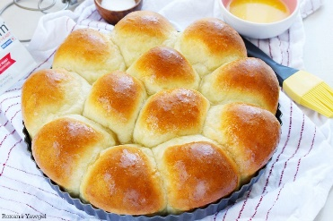¾ C Hot Water

½ C Sugar

1 Tablespoon Salt

3 Tablespoons Margarine

1 C Warm Water

2 Packs dry yeast

1 Egg

5 ¼ C Sifted Flour

Mix hot water, sugar, salt, margarine; cool until luke warm. Measure warm water into large bowl; sprinkle in yeast; stir until dissolved. Stir in lukewarm mixture, egg and 3 cups flour. Beat until smooth. Add the rest of the flour, mixing well. Place dough in greased bowl and brush top with soft margarine. Cover tightly with waxed paper or aluminum foil.

Refrigerate until doubled in bulk or until needed (4 days). To use pinch down, cut off the amount of dough required and form favorite shapes. Cover: let rise in warm draft-free place until doubled in bulk, about 1 hour. Brush with melted margarine. Bake in 400-degree oven about 10-15 minutes or until done.

**SECTION VI – ALL-AMERICAN APPLE PIE CONTEST**

PREMIUM: FIRST - $100.00; SECOND - $50.00; THIRD - $25.00

***Take in for PIES will be at 2:00 p.m on Saturday, September 17, 2022***

***Judging will be held at 3:00 p.m on Saturday, September 17, 2022***

***PIES will be taken at main exhibit building (A)***

1. 9 – 10-inch round PIE

2. Entries must be made from scratch. (Crusts and filling)

3. PIE will be judged on originality, taste and appearance.

4. Recipe must be submitted with entry.

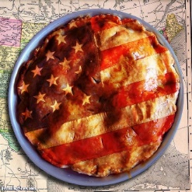

**SECTION VIII - CAKES**

PREMIUMS: FIRST - $10.00; SECOND - $7.00; THIRD - $5.00

Standards: Level or slightly rounded and uniform in thickness, light, tender, fine and uniform grain. Slightly moist Icing – smooth texture, good flavor and appropriate for cake. This does not apply to decorated cakes. No mixes.

CLASS

1. Pound or chiffon cake – ½ cake
2. Decorated cakes – Appearance only. Mock forms may be used. Will not cut or taste.
3. 4 cake pops – displayed on form/covered.

**SECTION IX – PIES**

PREMIUMS: FIRST - $5.00; SECOND - $3.00; THIRD - $2.00

CLASS

1. Fruit Pie (For example, fruit, cherry, apple, peach, etc.)

BAZ000092. Fried Pies (same list as above)

3. Tarts

**SECTION X – COOKIES**

PREMIUMS: FIRST - $5.00; SECOND - $3.00; THIRD - $2.00

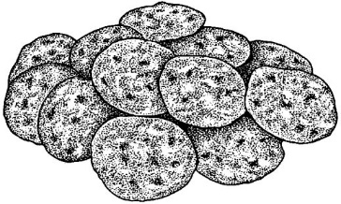CLASS

1. Brownies – three
2. Other Bar Type Cookies – three
3. Dropped Cookies - three
4. Pressed or Shaped – three

**SECTION XI – CANDY**

PREMIUMS: FIRST - $5.00; SECOND - $3.00; THIRD - $2.00

Smooth consistency, free of crystals, characteristics of type.

CLASS

1. Assortment – three varieties, two of each
2. Chocolate fudge – three pieces
3. Peanut butter fudge – three pieces
4. Mints – three pieces
5. Divinity and Sea foam – three pieces
6. Miscellaneous – three pieces

**SECTION XII– CANNED FOODS**

PREMIUMS: FIRST - $5.00; SECOND - $3.00; THIRD - $2.00

CLASS

1. Apple jelly
2. Crabapple jelly
3. Blackberry jelly
4. Grape jelly
5. Raspberry jelly
6. Hot pepper jelly
7. 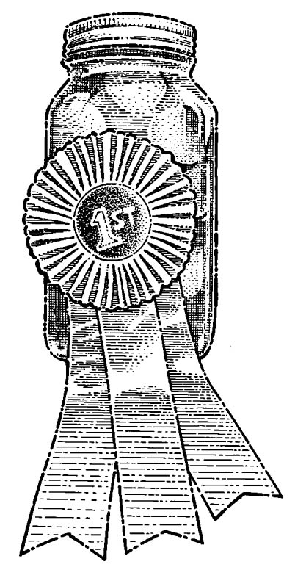Miscellaneous jelly
8. Peach preserves
9. Strawberry preserves
10. Miscellaneous preserves
11. Blackberry jam
12. Raspberry jam
13. Strawberry jam
14. Miscellaneous jam
15. Apple butter – crock pot
16. Apple butter – long cooked
17. Whole sweet cucumber pickles
18. Cubed sweet cucumber pickles
19. Sliced sweet cucumber pickles
20. Whole sour cucumber pickles
21. Sliced sour cucumber pickles
22. Dill pickles
23. Pickled Peppers
24. Squash or Zucchini pickles
25. Dilly beans or okra
26. Bread and Butter pickles
27. Miscellaneous pickled vegetables
28. Cucumber relish
29. Chow-Chow
30. Pepper relish
31. Miscellaneous relish
32. Pickled beets
33. Sweet potatoes
34. Green beans (cut)
35. Corn
36. Whole tomatoes
37. Stewed tomatoes
38. Tomato juice
39. Tomato sauce
40. October beans
41. Miscellaneous pepper
42. Kraut (jars must be sealed)
43. Soup mixture
44. Miscellaneous vegetables
45. Apples
46. Applesauce
47. Pears
48. Peaches
49. Grape juice
50. Miscellaneous fruit
51. Molasses and syrups
52. Spaghetti Sauce
53. Sauce (Ketchup, Barbeque, hot, etc)
54. Dehydrated fruit or vegetables
55. Salsa
56. 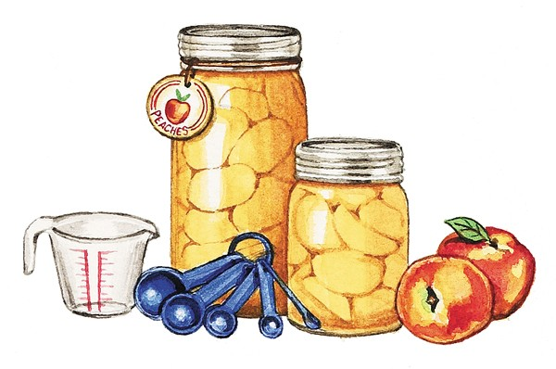Meats
57. Dried herbs

**DEPARTMENT C HORTICULTURE**

**CGX00077**

PREMIUMS: FIRST - $5.00; SECOND - $3.00; THIRD - $2.00

**RULES**

1. All plants must be clean and free from damage.
2. No greenhouse entries accepted.
3. All horticulture exhibits must have been grown by exhibitor.
4. All potted plants shall be in clean pots with no evidence of recent repotting; must have been in possession of exhibitor for at least three months.
5. Cut specimens should be displayed in beverage bottles or bud vases.
6. Plant shine will not be acceptable.
7. General rules and regulations apply to Horticulture exhibits.
8. Flowers should not be bigger than the container unless otherwise stated.
9. All plastic bottles should have rocks, marbles, etc in bottom to weigh down. Plastics should also have lids on them with holes drilled in top to help prevent spills.
10. No entries will be accepted after 6:00 p.m. unless in line before cut off.

CGC00051**SECTION A – MARIGOLDS**

Class 1 – Tall Yellow, one bloom

Class 2 – Tall Orange, one bloom

Class 3 – French – One spray

1. Double

**SECTION B – PETUNIAS**

Class 4 – Single – flowered – one bloom, any color

Class 5 – Ruffled (or double) – one bloom, any color

**SECTION C – ZINNIAS**

Class 6 – Large, Dahlia Flowered, one bloom, any color

Class 7 – Small Flowered – three blooms, any color

**SECTION D – DAHLIAS**

Class 8 – Large, over eight inches in diameter, one bloom, any color

Class 9 – Medium, four to eight inches, one bloom, any color

Class 10 – Miniature, under four inches, three blooms, any color

**SECTION E – ROSES**

Class 11 – Hybrid Teas – one bloom, any color

Class 12 – Climber, Rambler, Pillar, one stem, any color

Class 13 – Miniature, one bloom, any color

**SECTION F - CHRYSANTHEMUMS**

Class 14 – Double or semi-double, one spray

**SECTION G – COCKSCOMB OR CELOSIA**

Class 15 – Feathered or plumed, one stalk

Class 16 – Crested, one stalk

**SECTION H – COMBINATION POTS**

Class 17 – Annuals – five specimen – one of a kind or five kinds

**SECTION I – AFRICAN VIOLETS**

Class 18 – Single (any color)

Class 19 – Double (any color)

**SECTION J – POTTED FOLIAGE**

Class 20 – Blooming

1. Pot not over seven inches
2. Pot over seven inches

Class 21 – Non-blooming

1. 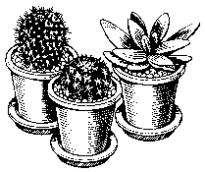Pot not over seven inches
2. Pot over seven inches

**SECTION K – SUCCULENTS**

Class 22 – Potted Succulents – Plant in proportion to pot size

Class 23 – Succulent Gardens – At least four varieties

**SECTION L – FERNS**

Class 24 – Boston

Class 25 – Asparagus

**SECTION M – HANGING BASKETS**

Class 26 – Blooming

Class 27 – Non-Blooming

**SECTION N – HERBS**

Class 28 – Potted Herbs

**SECTION O – ORCHIDS**

Class 29 – Petite Orchids

**SECTION P – FAIRY GARDENS**

Class 30 – Potted Fairy Gardens

**SECTION Q – COLEUS**

Class 31 – Coleus

**SECTION R – SUNFLOWERS**

Class 32 – Sunflower – Small Ornamental (no larger than 6 inches)

**DEPARTMENT D DESIGN DIVISION**

**Premiums – First $15.00; Second-$10.00; Third-$5.00**

**RULES**

1. One entry in each class per household is accepted.
2. No artificial flowers or foliage will be accepted unless specified. Dried materials may be used where specified.
3. Exhibits must be marked with name on bottom of container.
4. ONLY amateur designers may enter the "Amateur Class."

**AMATEUR CLASS**

1. “Home Grown Fun” – Arrangement using seasonal flowers with corn husks as the accessory.
2. “Virginia Creeper Trail” – Use a variety of colorful wild flowers to create a complementary color scheme.. Container of choice. No larger than 24” X 24”.

1. “Vertical Beauty” – Arrangements of fresh flowers suitable for Centerpiece.. No larger than 12” wide by 12” high. May have multiple containers to create look.
2. “Barter Theatre” – Arrangement of fresh black and white flowers suitable as a formal centerpiece. Size of arrangement should be a symmetrical design using a “Sock and Buskin” (Comedy & Tragedy Masks) symbol as an accessory. Arrangement should not exceed 24” in height.
3. “Fall Flavor” – Arrangement of fresh flowers using a seasoning or extract bottle. Arrangement should be no more than 6” high X 6” wide.

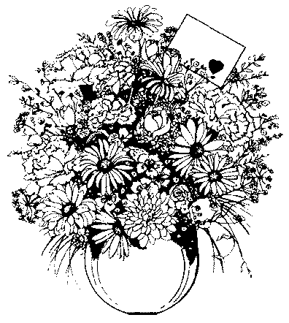

**INFORMATION**

**ENTERTAINMENT**

Jennifer Berry

Phone 276-451-0816

**RENTAL BOOTHS**

Henry Snodgrass

276-356-2994

Mike Overstreet

Phone 276-356-3129

**HOME ECONOMICS AND OUTH EXHIBITS**

Crystal Peek

Phone: 276-676-6309

**CROPS**

Phil Blevins

Phone: 276-676-6309

**PAGEANTS**

Debbie Icenhour

Phone: 276-23-3117

**PET SHOW**

Jennifer Berry

Phone: 276-451-0816

**HORSE SHOW**

Laura Boardwine

Phone 276-623-5783

**HONEY SHOW**

Jeremy Blackwell

abingdonbeecompany@gmail.com

**Washington County Fair**

**P.O. Box 711**

**Abingdon VA 24212**

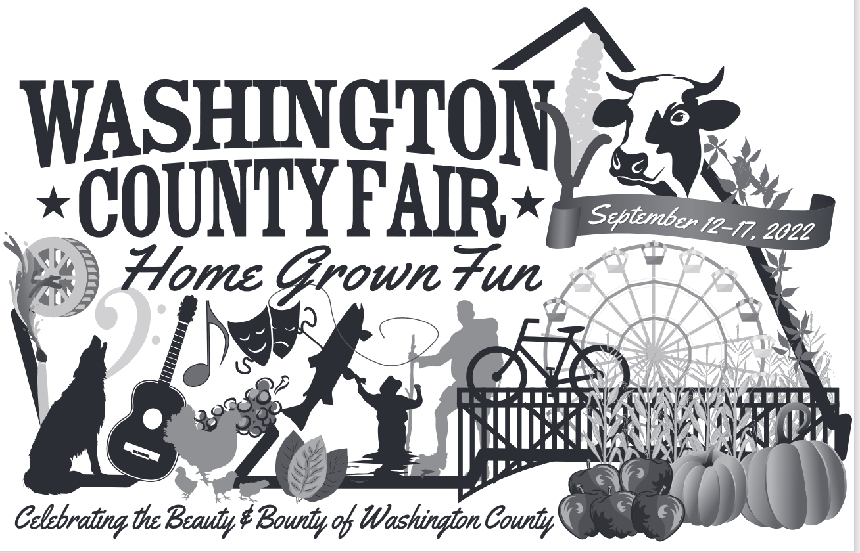

SAMPLE FAIR ENTRY TAG

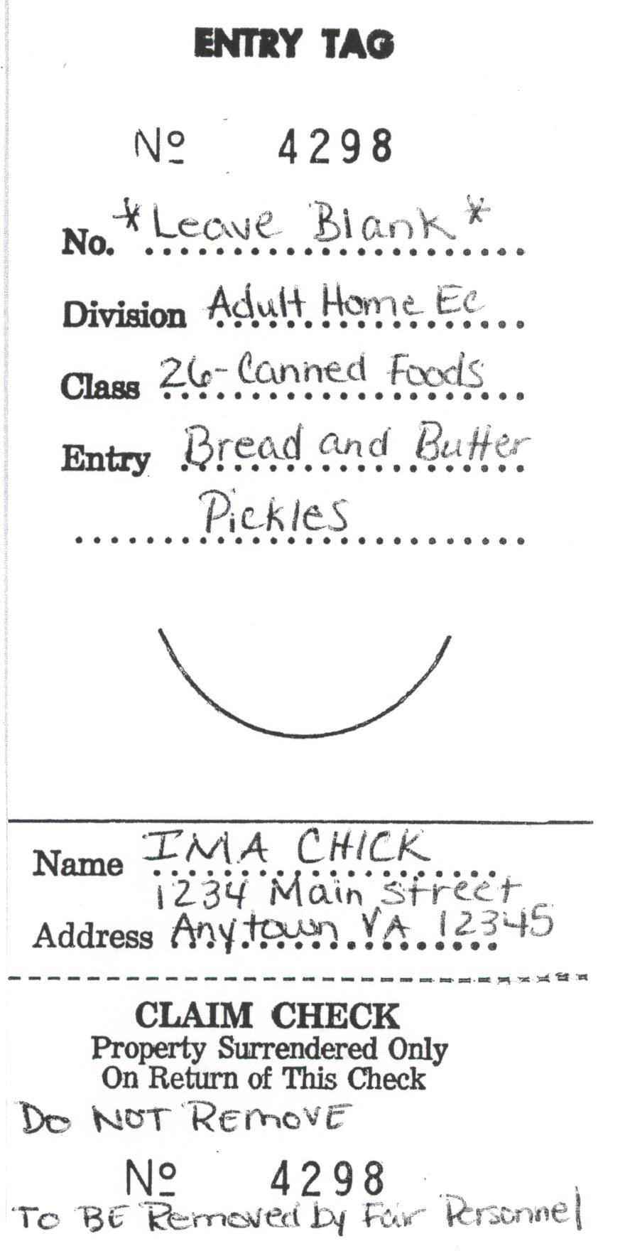

**(Sample tag taken from Adult Home Economics Department.**

**Please refer to fair book for correct entry information**

**In your department**

*Livestock*

**Dairy Cattle**

**Beef Cattle**

**Sheep**

**Goats**

**Poultry**

**Hogs**